CPE301 – SPRING 2019

Design Assignment 6

Student Name: Alex Cater

Student #: 2000583031

Student Email:cater@unlv.nevada.edu

Primary Github address: <https://github.com/katmando/asdfghjkl.git>

Submit the following for all Labs:

1. In the document, for each task submit the modified or included code (only) with highlights and justifications of the modifications. Also, include the comments.
2. Use the previously create a Github repository with a random name (no CPE/301, Lastname, Firstname). Place all labs under the root folder ESD301/DA, sub-folder named LABXX, with one document and one video link file for each lab, place modified asm/c files named as LabXX-TYY.asm/c.
3. If multiple asm/c files or other libraries are used, create a folder LabXX-TYY and place these files inside the folder.
4. The folder should have a) Word document (see template), b) source code file(s) and other include files, c) text file with youtube video links (see template).

1. **COMPONENTS LIST AND FLOW DIAGRAMS**

Atmega328PB Xplained Mini

Micro USB Cable (Power Supply)

Breadboard

MPU6050

Male-to-Male Wires

10k Ohm Resistor (x2)

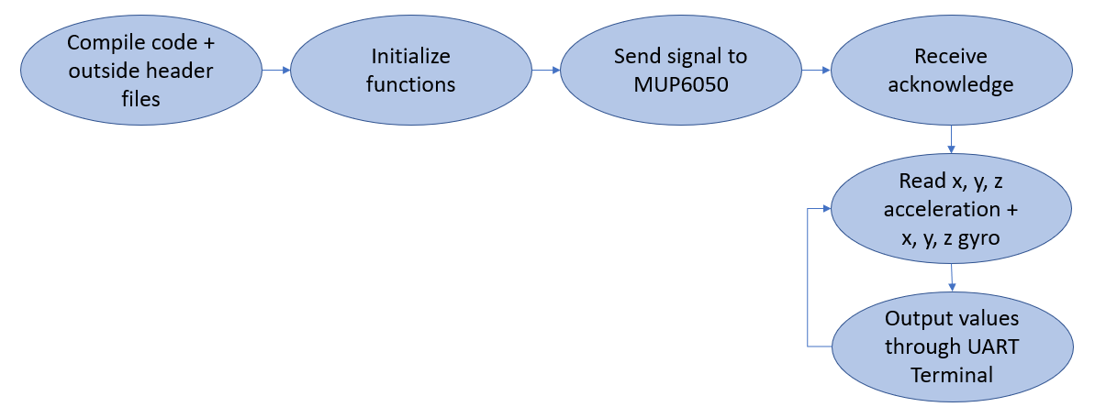

*Figure 1 – Flow Chart for Coding Algorithm in Task*

1. **INITIAL/DEVELOPED CODE OF TASK**

|  |
| --- |
| /* |
|  | * DA6.c |
|  | * |
|  | * Created: 5/4/2019 9:58:14 AM |
|  | * Author : acate |
|  | */ |
|  |  |
|  | #ifndef F_CPU |
|  | #define F_CPU 16000000UL |
|  | #endif |
|  |  |
|  | #include <avr/io.h> |
|  | #include <util/delay.h> |
|  | #include <math.h> |
|  | #include <stdlib.h> |
|  | #include <stdio.h> |
|  | #include "MPU6050_def.h" |
|  | #include "i2c_master.h" |
|  | #include "uart.h" |
|  |  |
|  | #define MPU6050_WRITE 0xD0 |
|  | #define MPU6050_READ 0xD1 |
|  |  |
|  | float Acc_x; |
|  | float Acc_y; |
|  | float Acc_z; |
|  | float Gyro_x; |
|  | float Gyro_y; |
|  | float Gyro_z; |
|  |  |
|  | void init_uart(uint16_t baudrate){ |
|  | uint16_t UBRR_val = (F_CPU/16)/(baudrate-1); |
|  | UBRR0H = UBRR_val >> 8; |
|  | UBRR0L = UBRR_val; |
|  | UCSR0B |= (1<<TXEN0) | (1<<RXEN0) | (1<<RXCIE0); |
|  | UCSR0C |= (1<<USBS0) | (3<<UCSZ00); |
|  | } |
|  |  |
|  | void uart_putc(unsigned char c){ |
|  | while(!(UCSR0A & (1<<UDRE0))); |
|  | UDR0 = c; |
|  | } |
|  |  |
|  | void uart_puts(char *s){ |
|  | while(*s){ |
|  | uart_putc(*s); |
|  | s++; |
|  | } |
|  | } |
|  |  |
|  | void init_MPU6050(void){ |
|  | _delay_ms(150); |
|  | i2c_start(MPU6050_WRITE); |
|  | i2c_write(SMPLRT_DIV); |
|  | i2c_write(0x07); |
|  | i2c_stop(); |
|  | i2c_start(MPU6050_WRITE); |
|  | i2c_write(PWR_MGMT_1); |
|  | i2c_write(0x01); // PLL with X axis gyroscope reference |
|  | i2c_stop(); |
|  | i2c_start(MPU6050_WRITE); |
|  | i2c_write(CONFIG); |
|  | i2c_write(0x00); |
|  | i2c_stop(); |
|  | i2c_start(MPU6050_WRITE); |
|  | i2c_write(GYRO_CONFIG); |
|  | i2c_write(0x18); |
|  | i2c_stop(); |
|  | i2c_start(MPU6050_WRITE); |
|  | i2c_write(INT_ENABLE); // DATA_RDY_EN = 1 |
|  | i2c_write(0x01); |
|  | i2c_stop(); |
|  | } |
|  |  |
|  | void getreading(void){ |
|  |  |
|  | i2c_start(MPU6050_WRITE); |
|  | i2c_write(ACCEL_XOUT_H); // set pointer |
|  | i2c_stop(); |
|  | i2c_start(MPU6050_READ); |
|  | Acc_x = (((int)i2c_read_ack()<<8) | (int)i2c_read_ack()); |
|  | i2c_stop(); |
|  |  |
|  | i2c_start(MPU6050_WRITE); |
|  | i2c_write(ACCEL_YOUT_H); // set pointer |
|  | i2c_stop(); |
|  | i2c_start(MPU6050_READ); |
|  | Acc_y = (((int)i2c_read_ack()<<8) | (int)i2c_read_ack()); |
|  | i2c_stop(); |
|  |  |
|  | i2c_start(MPU6050_WRITE); |
|  | i2c_write(ACCEL_ZOUT_H); // set pointer |
|  | i2c_stop(); |
|  | i2c_start(MPU6050_READ); |
|  | Acc_z = (((int)i2c_read_ack()<<8) | (int)i2c_read_ack()); |
|  | i2c_stop(); |
|  |  |
|  | i2c_start(MPU6050_WRITE); |
|  | i2c_write(GYRO_XOUT_H); // set pointer |
|  | i2c_stop(); |
|  | i2c_start(MPU6050_READ); |
|  | Gyro_x = (((int)i2c_read_ack()<<8) | (int)i2c_read_ack()); |
|  | i2c_stop(); |
|  |  |
|  | i2c_start(MPU6050_WRITE); |
|  | i2c_write(GYRO_YOUT_H); // set pointer |
|  | i2c_stop(); |
|  | i2c_start(MPU6050_READ); |
|  | Gyro_y = (((int)i2c_read_ack()<<8) | (int)i2c_read_ack()); |
|  | i2c_stop(); |
|  |  |
|  | i2c_start(MPU6050_WRITE); |
|  | i2c_write(GYRO_ZOUT_H); // set pointer |
|  | i2c_stop(); |
|  | i2c_start(MPU6050_READ); |
|  | Gyro_z = (((int)i2c_read_ack()<<8) | (int)i2c_read_ack()); |
|  | i2c_stop(); |
|  | } |
|  |  |
|  | int main(void){ |
|  | char buffer[20], float_[10]; |
|  | float Xa; |
|  | float Ya; |
|  | float Za; |
|  | float Xg; |
|  | float Yg; |
|  | float Zg; |
|  | init_uart(9600); |
|  | i2c_init(); |
|  | init_MPU6050(); |
|  |  |
|  | while(1){ |
|  | getreading(); |
|  | Xa = Acc_x/16384.0; |
|  | Ya = Acc_y/16384.0; |
|  | Za = Acc_z/16384.0; |
|  | Xg = Gyro_x/16.4; |
|  | Yg = Gyro_y/16.4; |
|  | Zg = Gyro_z/16.4; |
|  | dtostrf( Xa, 3, 2, float_ ); |
|  | sprintf(buffer,"%s Xa, ",float_); |
|  | USART_SendString(buffer); |
|  |  |
|  | dtostrf( Ya, 3, 2, float_ ); |
|  | sprintf(buffer,"%s Ya, ",float_); |
|  | USART_SendString(buffer); |
|  |  |
|  | dtostrf( Za, 3, 2, float_ ); |
|  | sprintf(buffer,"%s Za, ",float_); |
|  | USART_SendString(buffer); |
|  |  |
|  | dtostrf( Xg, 3, 2, float_ ); |
|  | sprintf(buffer,"%s Xg, ",float_); |
|  | USART_SendString(buffer); |
|  |  |
|  | dtostrf( Yg, 3, 2, float_ ); |
|  | sprintf(buffer,"%s Yg, ",float_); |
|  | USART_SendString(buffer); |
|  |  |
|  | dtostrf( Zg, 3, 2, float_ ); |
|  | sprintf(buffer,"%s Zg, ",float_); |
|  | USART_SendString(buffer); |
|  |  |
|  | USART_SendString("\r\n"); |
|  | _delay_ms(1000); |
|  | } |
|  |  |
|  | return 0; |
|  | } |

1. **SCHEMATICS**

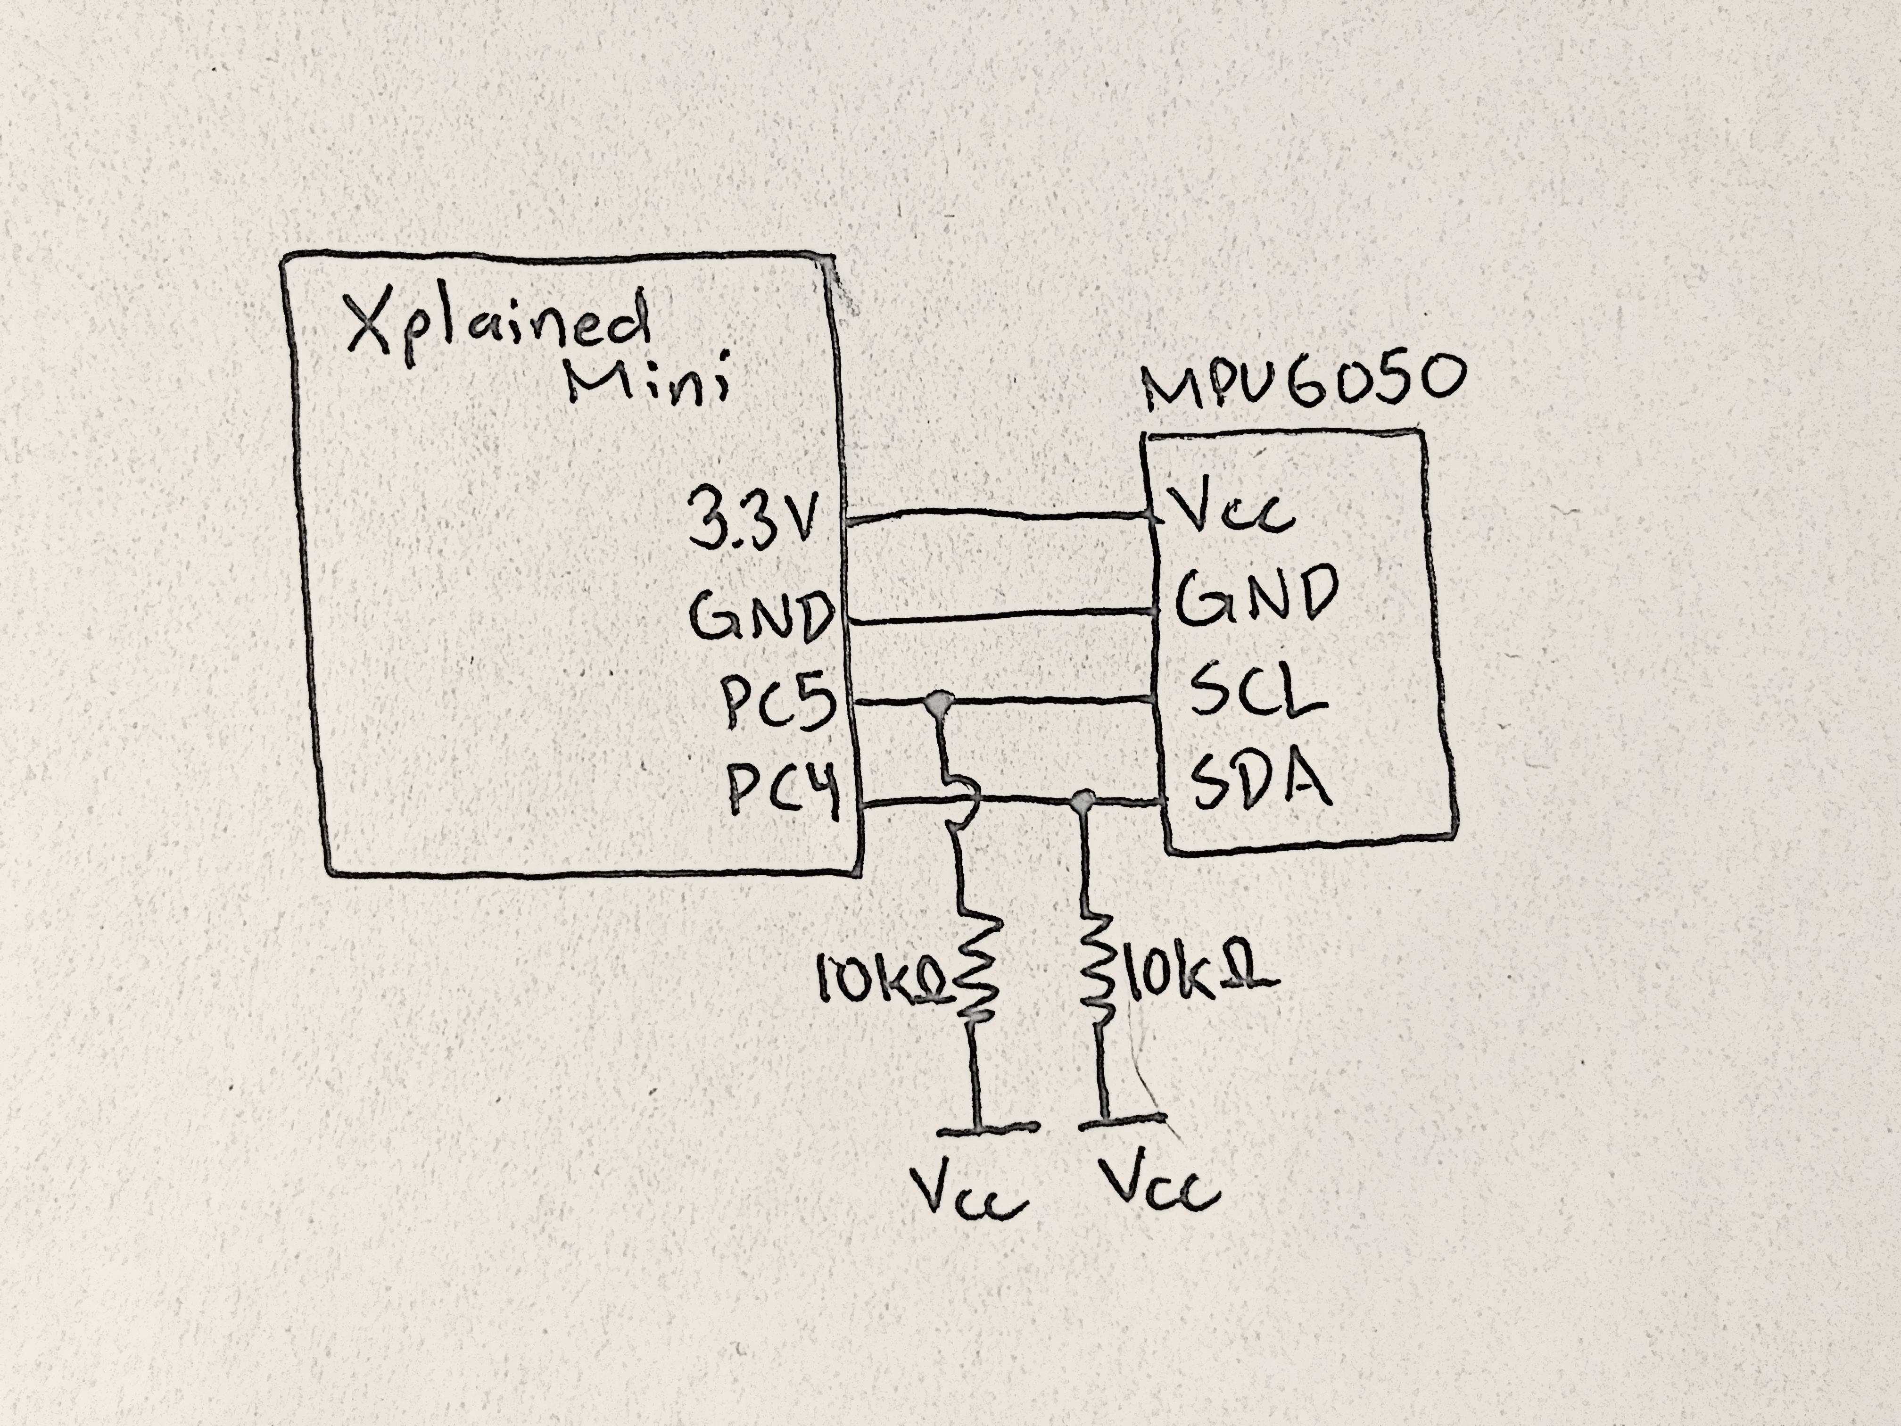

*Figure 2 – Atmega328P/PB Xplained Minis + MPU6050 I2C Module*

1. **SCREENSHOTS OF EACH TASK OUTPUT (ATMEL STUDIO OUTPUT)**

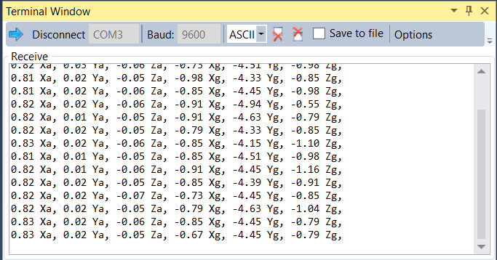

*Figure 3 – Output Terminal for Configuration of SPI Module*

There had been problems communicating data when the MPU6050 moved greatly, the terminal would stop reading values. MPU6050 could only change due to small changes in movement.

1. **SCREENSHOT OF EACH DEMO (BOARD SETUP)**

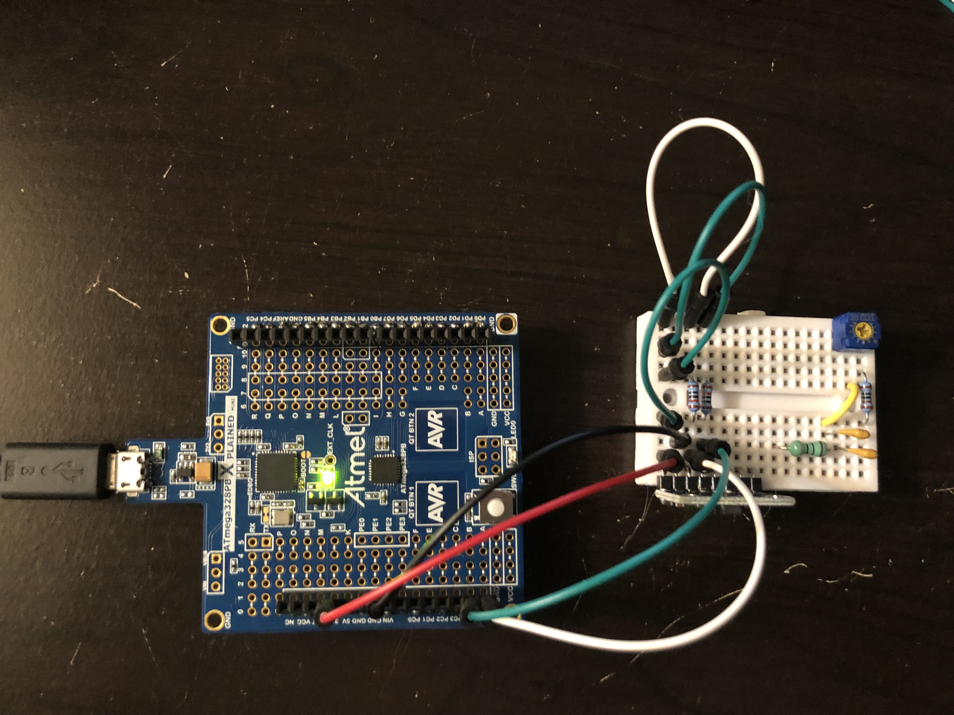

*Figure 4 – Connecting the Xplained Mini + MPU6050*

1. **VIDEO LINKS OF EACH DEMO**

N/A

1. **GITHUB LINK OF THIS DA**

https://github.com/katmando/asdfghjkl/tree/master/cpe301/DA6

**Student Academic Misconduct Policy**

<http://studentconduct.unlv.edu/misconduct/policy.html>

“This assignment submission is my own, original work”.

Alex Cater